To Do List Java Application:

Ashley Paddock, Danilo Da Silva

**Updated Application Requirements:**

Any tablet or computer device with a web browser that has Java runtime plug in enabled.

The application runs as a web based java applet.

**CRC Cards:**

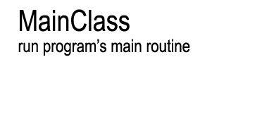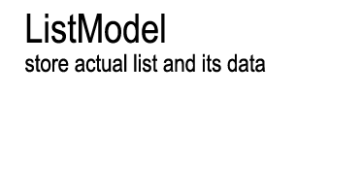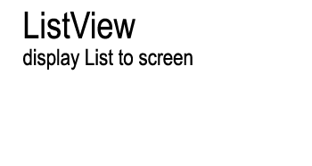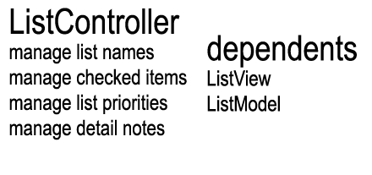

**UML Diagrams:**

Class Diagrams:

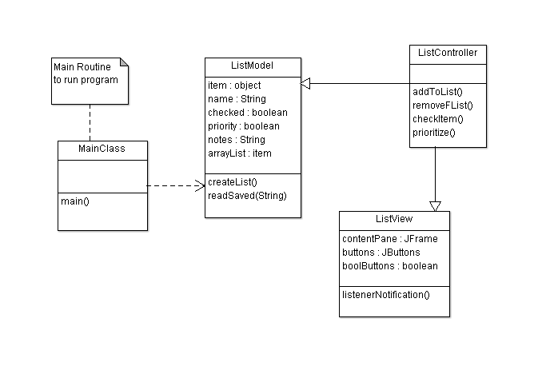

Sequence Diagram:

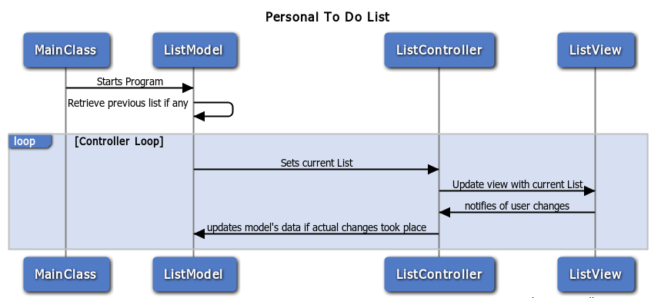

State Diagram:

